CAS PY 106

In-Class Note 10

1. Electrons moving through a direct current circuit
2. 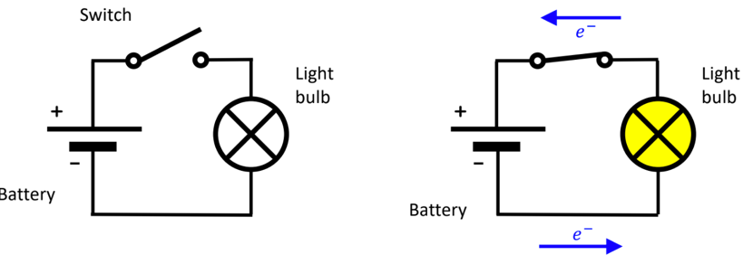
3. Light bulb is glowing because of flow of charge = current, I
4. I = Q/t is the amount of charge that flows per second
5. Unit for Current is ampere: 1A = 1C/S
6. Direction of current flow
7. 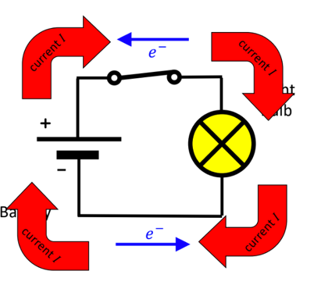
8. Opposite direction as flow of electrons (electrons go one way, current goes the other way)
9. Conductivity inside a wire
10. Inside the wire, electrons do not move in straight line
11. 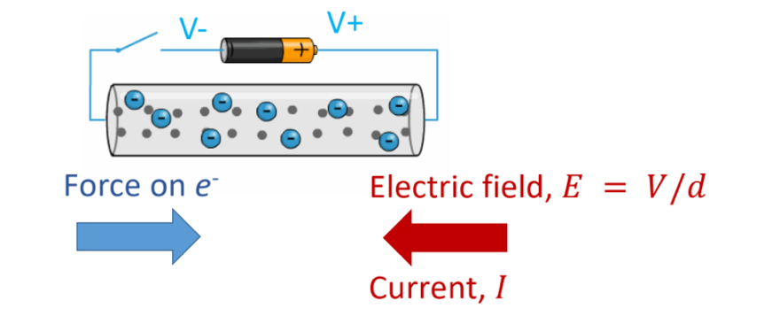
12. With no potential difference, electrons move randomly, colliding with atoms
13. With potential difference, they drift toward positive terminal
14. Electric current speed is due to energy transfer, wire is like wave energy guide
15. Light bulb has resistance
16. Light bulb resists the flow of electrons and then glows
17. 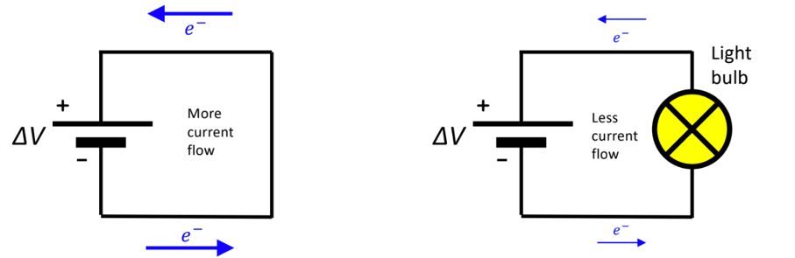
18. For same V, fewer electrons move through the circuit when the light bulb is there
19. Something with resistance is called a resistor
20. 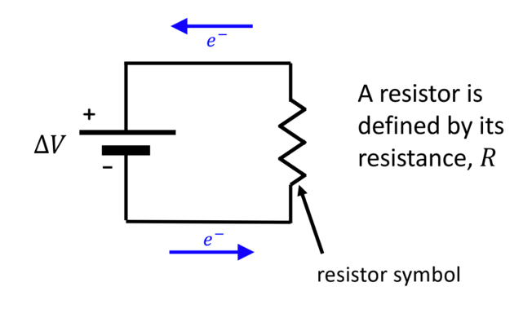
21. Ohm’s Law
22. Ohm’s law relates the potential difference across a resistor to the resistance and current flowing through it
23. V = I \* R 🡪 I = V/R
24. For the same potential difference, an object with more resistance will let fewer charges through per time 🡪 less current
25. Resistivity p
26. A block of material (size A \* L) has a resistance given by

R = p \* L / A

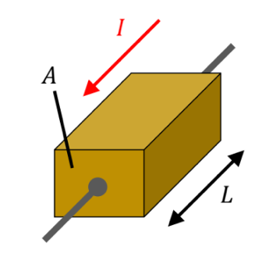

1. The coefficient p is called resistivity of material
2. Conductors have low resistivity and insulators have a high resistivity
3. Electric power
4. Because of all bumping around, electrons lose energy, and materials get hot
5. Power = amount of energy, Work, per second (in J/s or Watts)
6. P = I \* V
7. Using Ohm’s Law, we can write it as

P = I \* V

P = I^2 \* R

P = V^2 / R